Image | 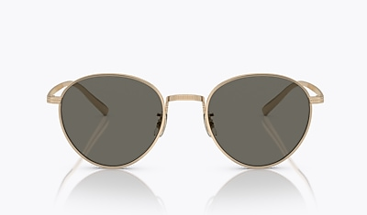
Brand | OLIVER PEOPLES
Model Name | Rhydian
Price | RS 5950
PRODUCT DETAILS

